**Analysis of EEG Signals by Machine Learning and Deep Learning Algorithms**

Project Report submitted in partial fulfillment of

The requirements for the degree of

**BACHELOR OF TECHNOLOGY**

In

**Applied Electronics and Instrumentation Engineering**

of

**MAULANA ABUL KALAM AZAD UNIVERSITY OF TECHNOLOGY**

by

**Ipsita Saha**, Roll No.: 10905519015

Under the guidance of

**Dr. Anuradha Saha**

DEPARTMENT OF APPLIED ELECTRONICS AND INSTRUMENTATION ENGINEERING



NETAJI SUBHASH ENGINEERING COLLEGE

**TECHNO CITY, GARIA, KOLKATA – 700 152**

2024-25

CERTIFICATE

This is to certify that this project report titled **Analysis of EEG Signals by Machine Learning and Deep Learning Algorithms** submitted in partial fulfillment of requirements for award of the degree Bachelor ofTechnology (B. Tech) in Applied Electronics and Instrumentation Engineering of West Bengal University of Technology is a faithful record of the original work carried out by,

**XXXXXX, Roll No. XXXXXX, Reg. No. XXXXXXXXX of XXXX-XXXX**

**XXXXXX, Roll No. XXXXXX, Reg. No. XXXXXXXXX of XXXX-XXXX**

Under my guidance and supervision.

It is further certified that it contains no material, which to a substantial extent has been submitted for the award of any degree/diploma in any institute or has been published in any form, except the assistances drawn from other sources, for which due acknowledgement has been made.

___________

**Date: ………..**

**Guide’s signature**

**Dr. Anuradha Saha**

Sd/__________________

**HOD In-charge of the Department**

AEIE

NETAJI SUBHASH ENGINEERING COLLEGE TECHNO CITY, GARIA, KOLKATA – 700 152

**DECLARATION**

We hereby declare that this project report entitled Analysis of EEG Signals by Machine Learning and Deep Learning Algorithms is our own original work carried out as a under graduate student in Netaji Subhash Engineering College except to the extent that assistances from other sources are duly acknowledged.

All sources used for this project report have been fully and properly cited. It contains no material which to a substantial extent has been submitted for the award of any degree/diploma in any institute or has been published in any form, except where due acknowledgement is made.

|  |  |  |
| --- | --- | --- |
| **Student’s names:** | **Signatures:** | **Dates:** |
| **XXXXX** | **……………………….** | **……………………..** |
| **XXXXX** | **……………………….** | **……………………..** |

**CERTIFICATE OF APPROVAL**

We hereby approve this dissertation titled

**Analysis of EEG Signals by Machine Learning and Deep Learning Algorithms**

Carried out by

**XXXXXXX,**

Roll No.: XXXXX,

Reg. No.: XXXXXX of XXXX-XXXX

**XXXXXXX,**

Roll No.: XXXXX,

Reg. No.: XXXXXX of XXXX-XXXX

Under the guidance of

**Dr. Anuradha Saha**

of Netaji Subhash Engineering College, Kolkata in partial fulfillment of requirements for award of the

degree Bachelor of Technology (B. Tech) in AEIE of West Bengal University of Technology

**Date: ………..**

**Examiners’ signatures:**

1. ………………………………………….
2. ………………………………………….
3. ………………………………………….

**Acknowledgement**

We would like to take this opportunity to acknowledge and thank those who made this work possible and unforgettable to us.

First and foremost, we would like to express our heartfelt gratitude to our guide Dr. Anuradha Saha, for her constant encouragement, able guidance and for giving us a new platform to build our career by giving us a chance to learn different fields of this technology. We are grateful for what she has provided us.

We would also like to express our gratitude to our HoD In-Charge Sir, Prof. Sumitesh Majumder, for his constant support throughout our project. We would also like to thank all the faculty members of our department for helping us in all the possible ways.

We would also like to thank Principal Sir, Prof.(Dr.) Amal Kumar Ghosh and Director Sir, Dr. H. K. Mondal of Netaji Subhas Engineering College for their constant encouragement and support throughout the project.

We would also like to thank our friends for their support and encouragement. Without their support it would not have been possible.

Last but not the least we would like to express our sincere gratitude to our alma mater, Netaji Subhas Engineering College, which provided us with all the necessary facilities required in completion of this project.

…………………………. XXXXXXX

Dated: …………………………

Place: ………………………….

ABSTRACT

Electroencephalography (EEG) is the recording of electrical activity along the scalp. EEG measures voltage fluctuations resulting from ionic current flows within the neurons of the brain. In clinical contexts, EEG refers to the recording of the brain's spontaneous electrical activity over a short period of time, usually 20–40 minutes, as recorded from multiple electrodes placed on the scalp. EEG is most often used to diagnose epilepsy, which causes obvious abnormalities in EEG readings. It is also used to diagnose sleep disorders, coma, encephalopathies, and brain death.

In our current work we have studied and applied different neuro-signal processing methods based on EEG. EEG signals are classified into different bands. First we proceed with the artifact removal, then processing of EEG data and classification of the signals. The data set was recorded from the experiment conducted on 9 subjects under different conditions. They were told to move their left hand, right hand, legs and tongue. The data was collected by placing 22 EEG electrodes on the scalp and 3 electrodes for EOG data.

The raw data contains some artifacts (noise). This was removed by applying wavelet transform based adaptive filter. Also using the availability of EOG signal data, we can reduce the artifacts in the EEG data in all channels through estimation of the channel between the EOG and each channel of EEG electrodes. The estimation can be done by many different algorithms. In this project the first attempt made was an adaptive filter. Here the adaptive filter is given the inputs of the 3 EOG channels and is tasked with the estimation of the EEG channel. The adaptive filters applied to each EOG signal try to estimate the EEG signal based on the same common input in three different stages. The raw EEG scalp potentials are known to have a poor spatial resolution owing to volume conduction. Hence it is difficult to capture the signals of interest. We use a technique called Common Spatial Pattern (CSP) to analyze multichannel data based on recordings from two classes (conditions). CSP yields a data-driven supervised decomposition of the signal parameterized by a matrix. CSP filters maximize the variance of the spatially filtered signal under one condition while minimizing it for the other condition. After processing of EEG signals we now classify the signals using Support Machine Vector (SVM) algorithm. We were able to classify the signals with a classification rate of 95%.



ACKNOWLEDGEMENT

**Table of Contents**

**1** **EEG Introduction ...........................................................................**

1.1 EEG generation from the brain .................................................................................

1.2 Applications of EEG signal processing ......................................................................

1.3 Characteristics of EEG signals ...................................................................................

1.3.1 Delta Waves .......................................................................................................

1.3.2 Theta Waves ......................................................................................................

1.3.3 Alpha Waves ......................................................................................................

1.3.4 Beta Waves ........................................................................................................

1.3.5 Gamma Waves ...................................................................................................

1.4 EEG recording systems .............................................................................................

1.4.1 Requirements and Current Standards ...............................................................

1.4.2 Modes of Recording ...........................................................................................

1.4.3 Electrode Placement Standards .........................................................................

**2** **Data Description ...........................................................................**

2.1 Experimental Conditions ..........................................................................................

2.2 Data Collection and Properties .................................................................................

**3** **EEG Signal Processing Methods ......................................................**

3.1 Pre Processing Methods ...........................................................................................

3.1.1 Artifacts Commonly Observed ...........................................................................

3.1.2 Some common filters .........................................................................................

3.2 Wavelet Transform Based Adaptive Filtering ...........................................................

3.2.1 What is a Wavelet? ............................................................................................

3.2.2 Continuous Wavelet Transform .........................................................................

3.2.3 Discrete Wavelet Transform ..............................................................................

3.2.4 Stationary Wavelet Transform ...........................................................................

1. **PCA reduction of EEG signals .........................................................**
2. **Artifact Reduction using EOG signals ..............................................**

5.1.1 Basic Adaptive filtering ......................................................................................

5.1.2 Conditioning of EOG signals ...............................................................................

5.1.3 Stationary Wavelet Transform as a preprocessing method ..............................

5.2 Interpretation of the filter coefficients ....................................................................

**6** **Spatial Filtering .............................................................................**

6.1 Neurophysiological Background ...............................................................................

6.2 Need for spatial filtering ...........................................................................................

6.3 Introduction to CSP Analysis .....................................................................................

6.4 CSP Results ...............................................................................................................

**7** **Classification using Support Vector Machine (SVM) ........................**

7.1 Support Vector Machine ..........................................................................................

7.1.1 Mathematical Explanation .................................................................................

**8** **Matlab Code .................................................................................**

8.1 Code For Organizing Data into a Readable Format ..................................................

8.2 Artifact Removal With Adaptive Filtering .................................................................

8.3 Common Spatial Patterns Program ..........................................................................

8.4 Support Vector Machines for Classification .............................................................

8.5 Complete Program Executing all components to make a complete prediction

1. **Results ..........................................................................................**
2. **Future Directions**
3. **References ....................................................................................**

Analysis of EEG Signal

1. **EEG INTRODUCTION**

**1.1** **EEG GENERATION FROM THE BRAIN**

When neurons are activated, they produce synaptic currents which then induce a magnetic field measurable by EMG and a secondary electrical field over the scalp measurable by EEG. The human head consists of different layers including the scalp, skull, brain and many other thin layers in between. The skull attenuates the signals approximately one hundred times more than the soft tissue. On the other hand, most of the noise is generated either within the brain (internal noise) or over the scalp (system noise or external noise).Therefore, only large populations of active neurons can generate enough potential to be recordable using the scalp electrodes. These measurements are then amplified greatly before further processing.

**1.2** **APPLICATIONS OF EEGSIGNAL PROCESSING**

* Monitoring alertness, coma, and brain death;
* Locating areas of damage following head injury, stroke, and tumor;
* Testing afferent pathways (by evoked potentials);
* Monitoring cognitive engagement (alpha rhythm);
* Producing biofeedback situations;
* Controlling anesthesia depth (servo anesthesia);
* Investigating epilepsy and locating seizure origin;
* Testing epilepsy drug effects;
* Assisting in experimental cortical excision of epileptic focus;
* Monitoring the brain development;
* Testing drugs for convulsive effects;
* Investigating sleep disorders and physiology;

**1.3** **CHARACTERISTICS OF EEG SIGNALS**

EEG signals reflect often brain rhythms that reflect the current state of the brain for example sleep or wakefulness. The main characteristics that are used to make inferences about the brain rhythms are the frequency and amplitude of the signal. These characteristics are however not independent of other factors and often change with age and also show variations from person to person.

The main brain waves distinguished by frequency are listed below.

**1.3.1 Delta Waves**

Delta waves lie within the range of 0.5–4 Hz. These waves are primarily associated with deep sleep and may be present in the waking state. It is very easy to confuse artifact signals caused

by the large muscles of the neck and jaw with the genuine delta response. This is because the muscles are near the surface of the skin and produce large signals, whereas the signal that is of interest originates from deep within the brain and is severely attenuated in passing through the skull. Signal processing methods need to be applied to distinguish genuine delta responses from artifacts.

**1.3.2 Theta Waves**

Theta waves lie within the range of 4–7.5 Hz. They are generally associated with access to subconscious material and creative inspiration or deep meditation. The theta wave plays an important role in infancy and childhood. Larger contingents of theta wave activity in the waking adult are abnormal and are caused by various pathological problems. The changes in the rhythm of theta waves have been used in maturational and emotional studies.

**1.3.3 Alpha Waves**

Lie in the range of 8-13 Hz and are mostly recorded over the posterior part of the brain called the occipital region of the brain. Most commonly they are rounded or sinusoidal in shape but in rare cases observed to have sharp negative peaks with rounded positive peaks. Alpha waves have been thought to indicate both a relaxed awareness without any attention or concentration. The alpha wave is the most prominent rhythm in the whole realm of brain activity and possibly covers a greater range than has been previously documented. Peaks have been observed in both the beta and the other ranges while in an alpha setting, showing alpha characteristics. The normal amplitude of the alpha wave is around 50uV. The origin and the significance of the alpha wave is an active research area.

**1.3.4 Beta Waves**

A beta wave is the electrical activity of the brain varying within the range of 14–26 Hz. A beta wave is the usual waking rhythm of the brain associated with active thinking, active attention, focus on the outside world, or solving concrete problems, and is found in normal adults. A high-level beta wave may be acquired when a human is in a panic state. Rhythmical beta activity is encountered chiefly over the frontal and central regions. Importantly, a central beta rhythm can be blocked by motor activity or tactile stimulation. The amplitude of beta rhythm is normally under 30µV.

**1.3.5 Gamma Waves**

The frequencies above 30 Hz correspond to the gamma range. Although the amplitudes of these rhythms are very low and their occurrence is rare, detection of these rhythms can be used for confirmation of certain brain diseases. The regions of high EEG frequencies and highest levels of cerebral blood flow (as well as oxygen and glucose uptake which are relevant to fMRI measurements) are located in the fronto-central area. The gamma wave band has also been proved to be a good indication of event-related synchronization (ERS) of the brain and can be used to demonstrate the locus for right and left index finger movement, right toes, and the rather broad and bilateral area for tongue movement.

The image shows the various types of waves described above and their frequency bands. Note that here the gamma waves are included in the beta range. This is a somewhat prevalent practice and the gamma waves are sometimes called fast beta waves.

These rhythms are cyclic in nature and correspond to the steady state responses of the brain, in addition to these transients such as an event-related potential (ERP) and containing positive occipital sharp transient (POST) signals (also called rho (ρ) waves) may be observed in EEG signals. Artifacts caused by the eye interference such as fluttering of eyelids may be similar to an alpha rhythm in the posterior part of the brain and need to be filtered out. Other extraneous signals may be caused by any bone defects or brain malfunction.

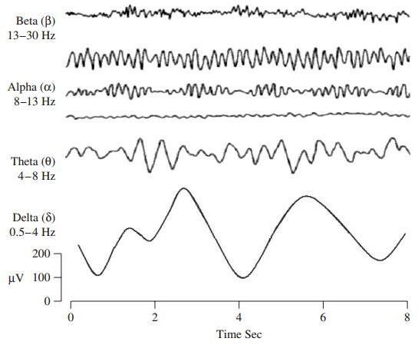

**1.4** **EEG RECORDING SYSTEMS**

**1.4.1 Requirements and Current Standards**

More recent EEG systems consist of a number of delicate electrodes, a set of differential amplifiers (one for each channel) followed by filters. The conversion from analogue to digital EEG is performed by means of multichannel analogue-to-digital converters (ADCs) The EEG signals are generally restricted to within 100Hz and hence require only a sampling rate of around 200Hz to be completely captured with no aliasing. Applications exist that can even do with 100Hz of sampling rate. For very fine observation of the EEG signals, rarely 2000 Hz sampling rate is used in very high precision applications. Although a low sampling rate will suffice, we need a high accuracy in quantization and hence 16 bit or higher quantization is often employed in EEG signal recording. Given these system parameters, we can calculate that for a 128 electrode system with 500 Hz sampling, approximately 0.5 Gb of memory is required.

The EEG recording electrodes and their proper function are crucial for acquiring high quality data.

Different types of electrodes are often used in the EEG recording systems, such as:

* disposable (gel-less, and pre-gelled types);
* reusable disc electrodes (gold, silver, stainless steel, or tin);
* headbands and electrode caps;
* saline-based electrodes;
* Needle electrodes.

For multichannel recordings with a large number of electrodes, electrode caps are often used. Commonly used scalp electrodes consist of Ag–AgCl disks, less than 3 mm in diameter, with long flexible leads that can be plugged into an amplifier. Needle electrodes are those that have to be implanted under the skull with minimal invasive operations. High impedance between the cortex and the electrodes as well as the electrodes with high impedances can lead to distortion, which can even mask the actual EEG signals. Commercial EEG recording systems are often equipped with impedance monitors. To enable a satisfactory recording the electrode impedances should read less than 5 k-ohm and be balanced to within 1 k-ohm of each other. For more accurate measurement the impedances are checked after each trial.

**1.4.2 Modes of Recording**

Two different modes of recordings, namely differential and referential, are used. In the differential mode the two inputs to each differential amplifier are from two electrodes. In the referential mode, on the other hand, one or two reference electrodes are used. Several different reference electrode placements can be found in the literature. Physical references can be used as vertex (Cz), linked-ears, linked-mastoids, contralateral ear, C7, bipolar references, and tip of the nose. There are also reference-free recording techniques, which actually use a common average reference. The choice of reference may produce topographic distortion if the reference is not relatively neutral. In modern instrumentation, however, the choice of a reference does not play an important role in the measurement.

**1.4.3 Electrode Placement Standards**

The diagram below represents the placement of 21 electrodes in a standard recommended system called the 10-20 system.

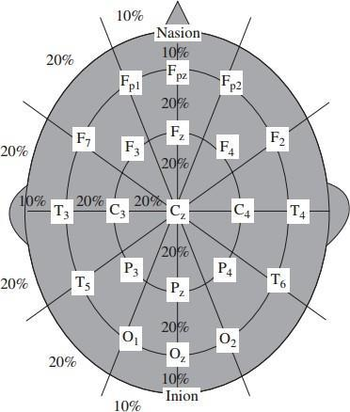

Several other recording systems exist for example; in the conventional 10–20 system has been modified to capture better the signals from epileptic foci in epileptic seizure recordings. The only difference between this system and the 10–20 conventional system is that the outer electrodes are slightly lowered to enable better capturing of the required signals. The advantage of this system over the conventional one is that it provides a more extensive coverage of the lower part of the cerebral convexity which is important for epilepsy studies. Many systems have been proposed by researchers over the years mostly to cater to various specialized needs.

The diagram in the right shows a more detailed diagram of the 10-20 system for the placement of 75 electrodes around the skull:

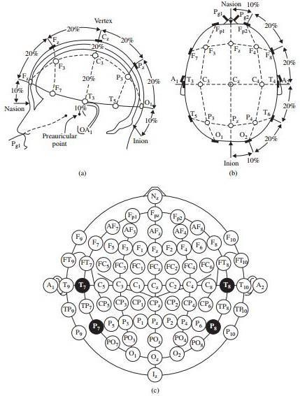

1. **DATA DESCRIPTION**

**2.1** **EXPERIMENTAL CONDITIONS**

This data set consists of EEG data from 9 subjects. The cue-based BCI paradigm consisted of four different motor imagery tasks, namely the imagination of movement of the left hand (class 1), right hand (class 2), both feet (class 3), and tongue (class 4). Two sessions on different days were recorded for each subject. Each session is comprised of 6 runs separated by short breaks. One run consists of 48 trials (12 for each of the four possible classes), yielding a total of 288 trials per session. At the beginning of each session, a recording of approximately 5 minutes was performed to estimate the EOG influence. The recording was divided into 3 blocks: (1) two minutes with eyes open (looking at a fixation cross on the screen), (2) one minute with eyes closed, and (3) one minute with eye movements. The timing scheme of one session is illustrated in Figure 1.

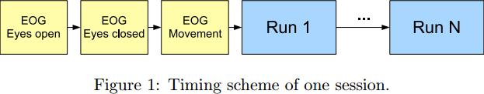

The subjects were sitting in a comfortable armchair in front of a computer screen. At the beginning of a trial (t = 0 s), a fixation cross appeared on the black screen. In addition, a short acoustic warning tone was presented. After two seconds (t = 2 s), a cue in the form of an arrow pointing either to the left, right, down or up (corresponding to one of the four classes left hand, right hand, foot or tongue) appeared and stayed on the screen for 1.25 s. This prompted the subjects to perform the desired motor imagery task. No feedback was provided. The subjects were ask to carry out the motor imagery task until the fixation cross disappeared from the screen at t = 6 s. A short break followed where the screen was black again. The paradigm is illustrated in Figure 2

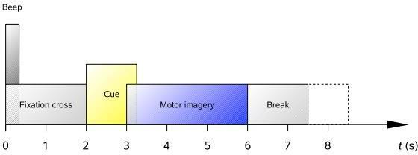

**2.2** **DATA COLLECTION AND PROPERTIES**

Twenty-two Ag/AgCl electrodes (with inter-electrode distances of 3.5 cm) were used to record the EEG; the montage is shown in Figure 3 left. All signals were recorded monopolarly with the left mastoid serving as reference and the right mastoid as ground. The signals were sampled with 250 Hz and bandpass-filtered between 0.5 Hz and 100 Hz. The sensitivity of the amplifier was set to 100 µV. An additional 50 Hz notch filter was enabled to suppress line noise.

In addition to the 22 EEG channels, 3 monopolar EOG channels were recorded and also sampled with 250 Hz (see Figure 3 right). They were bandpass filtered between 0.5 Hz and 100 Hz (with the 50 Hz notch filter

enabled), and the sensitivity of the amplifier was set to 1 mV. The EOG channels are provided for the subsequent application of artifact processing methods [1] and must not be used for classification. A visual inspection of all data sets was carried out by an expert and trials containing artifacts were marked.

The electrode placement scheme is shown below for reference.

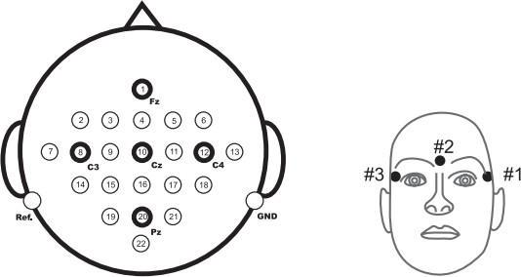

1. **EEG SIGNAL PROCESSING METHODS**

**3.1** **PRE PROCESSING METHODS**

**3.1.1 Artifacts Commonly Observed**

The main Artifacts can be divided into patient-related (physiological) and system Artifacts. The patient-related or internal artifacts are body movement-related, EMG, ECG (and pulsation), EOG, and sweating. The system artifacts are 50/60 Hz power supply interference, impedance fluctuation, cable defects, electrical noise from the electronic components, and unbalanced impedances of the electrodes.

**3.1.2 Some common filters**

The raw EEG signals are of the magnitude of few micro volts and have frequency content up to 300Hz in general. These signals need to be amplified, filtered for noise before further interpretation. Amplification can be done before or after the ADC. Some standard filters used are mentioned below.

1. High pass filters with a cut-off frequency of usually less than 0.5 Hz are used to remove the disturbing very low frequency components such as those of breathing.
2. Low pass filters with a cut-off frequency of approximately 50–70 Hz to remove high frequency noise.
3. Notch filters with a null frequency of 50 Hz are often necessary to ensure perfect rejection of the strong 50 Hz power supply

**3.2** **WAVELET TRANSFORM BASED ADAPTIVE FILTERING**

The finite oscillatory nature of the wavelet makes them extremely useful in real life situations in which signals are not stationary. While Fourier transform of a signal offers only frequency

resolution, wavelet transform offer “variable time-frequency” resolution which is the hallmark of wavelet transforms.

A wavelet transform decomposes the signal into basis functions which are known as wavelets. Wavelet transform is calculated separately for different segments of time-domain signal at different frequencies resulting in Multi-resolution analysis or MRA. It is designed in such a way that the product of the time resolution and frequency resolution is constant. Therefore it gives good time resolution and poor frequency resolution at high frequencies whereas good frequency and poor time resolution at low frequencies. This feature of MRA makes it excellent for signals having high frequency components for short durations and low frequency components for long duration. E.g. noise in signals, images, video frames etc.

**3.2.1 What is a Wavelet?**

Wavelets are mathematical functions with oscillatory nature similar to sinusoidal waves with the difference being that they are of “finite oscillatory nature”. For a function defined over real axis, to be classed as a wavelet, it must satisfy the following three properties:

|  |  |  |  |  |  |  |  |  |
| --- | --- | --- | --- | --- | --- | --- | --- | --- |
| ▪ | The integral of ψ(t) is zero | ∫∞ | | () =0  | | |  |  |
|  |  | −∞ | |  |  |  |  |  |
| ▪ | The integral of the square of ψ(t) is unity ∫∞ | | | | | | ψ2() =1  |  |
| ▪ |   | | ∞ (|ψ( )|)^2 | | | −∞ |  |  |
|  | satisfies 0 < C <∞ |  |
|  | Admissibility Condition C | = | ∫ |  |  |  |
|  |  | ψ | 0 |  |  |  | ψ |  |
|  |  |  |  |  |  |  |

Examples of Wavelets

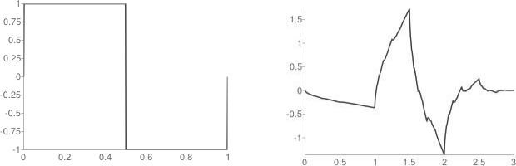

Haar Wavelet Daubchies 2 Wavelet

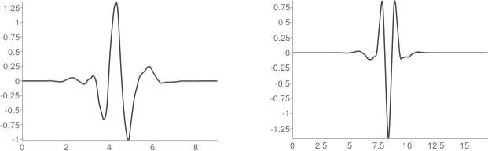

Symlet 5 wavelet Coiflet 3 Wavelet

**3.2.2 Continuous Wavelet Transform**

A basic wavelet transform of the signal x(t) has the following form:

|  |  |  |  |  |  |  |  |
| --- | --- | --- | --- | --- | --- | --- | --- |
|  | 1 | |  |  | − | ) ( ) |  |
| (,)= | |  |  | ∫ ( |  |  |
|  |  |  | |  |
|  | √ | | |  |  |

where ψ(t) is the mother wavelet and acts as a window function to localize the integration and a, b are dilation and translation factors respectively.

**3.2.3 Discrete Wavelet Transform**

The signal x(t) is analyzed over infinitely many dilations and translations of the mother wavelet. Clearly there will be a lot of redundancy in the CWT. We can in fact retain the key features of the transform by only considering subsamples of the CWT. This leads us to the discrete wavelet transform (DWT). Generally, the orthogonal wavelets are employed because this method associates the wavelet to orthonormal bases of L2(R).

The DWT operates on discretely sampled function or time series x (t), usually defining time t=0, 1, 2… N-1 to be finite. It analyses the time series of discrete dilations and translations of the mother wavelet i.e. a and b take only integral values.

|  |  |  |  |  |  |  |  |  |  |  |  |  |  |  |
| --- | --- | --- | --- | --- | --- | --- | --- | --- | --- | --- | --- | --- | --- | --- |
| Let a=a0j and b=b0k where j, k ϵ*Z*. In this case the discretized wavelet function is | | | | | | | | | | | | | |  |
| ( ) = | 1 | |  |  | − 0 0 | | | | |  |  |  |  |  |
|  |  |  | ( |  |  |  |  |  |
|  |  |  |  |  |  |  | ), and its wavelet transform is given by | | | | | |  |
|  |  |  | 0 |  |  |  |
|  | √ 0 | |  |  |  |
|  |  | (, )= | | | | 1 | | | |  | ∫()( | − 0 0 | ) |  |
|  |  |  |  |  |  |  |
|  |  |  |  |  |  | √ 0 | | | |  |  | 0 | |  |

Given dj(k) = Wx(j, k) we hope to recover x(t) from formula like

∞ ∞

()=∑∑ () ()

=0 =−∞

This formula is called the wavelet series where dj(k) is wavelet coefficient and Ψjk(t) is the dual wavelet. The dual wavelet can be determined using Daubechies wavelet frame theory.

**3.2.3.1 DWT Implementation using Pyramid Algorithm**

The actual process involved in DWT calculation is as follows:

•

•

The signal is decomposed into one or more levels of resolution (Octaves).

The low pass filter produces the average signal, while the high pass filter produces detail signal.

* In Multi Resolution Analysis (MRA), the average signal at one level is sent to another set of filters, which produces the average and detail signals at the next octave.
* The low pass filter applies a scaling function to the signals, while the high pass filter applies the wavelet function.
* Applying the following difference equation with the scaling function’s coefficients, h, gives an approximation of the signal. This is also known as the low pass output, where W are the

scaling coefficients, and j represents the octave.

2

(,)=∑ (−1, )ℎ(2 − )

=0

where W(j, n) is the nth scaling coefficient at the jth stage.

* Convolution with the wavelet function’s coefficients, g, produces the detail signal, also called

high pass output Wh

2

ℎ(,)=∑ (−1, )(2− )

=0

where, Wh(j, n) is the nth wavelet coefficient at the jth stage

* The DWT of a signal can be computed recursively using a pair of filter with the fast pyramid algorithm, by Mallat and Meyer.

Three Octave Decomposition of a Signal

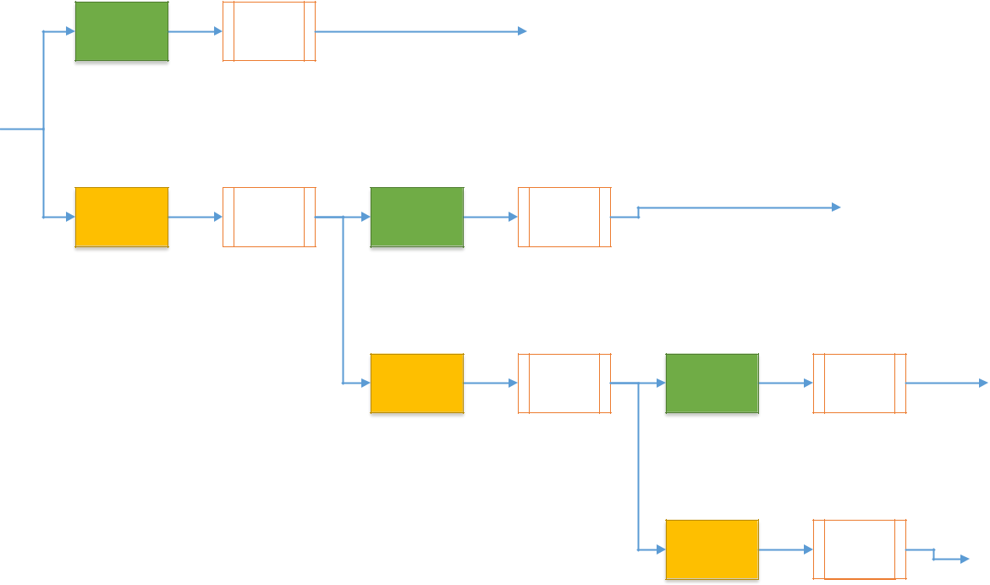

IN

High Pass

Low Pass

Downsample

by 2

Downsam

ple by 2

High Pass

Detail 1

Downsam

ple by 2

Detail 2

Low Pass

Downsam

ple by 2

High Pass

Downsam

ple by 2

Detail

3

Low Pass

Approximate

Signal

Downsam

ple by 2

1- Dimensional Signal Analysis and Synthesis Using DWT

|  |  |  |  |  |  |  |  |  |  |
| --- | --- | --- | --- | --- | --- | --- | --- | --- | --- |
|  |  |  | Analysis | |  | Synthesis | | |  |
|  |  |  |  | Down | Up |  |  | Inverse High |  |
|  |  | High Pass |  | Sample | Sample |  |  |  |
|  |  |  |  |  | Pass |  |
|  |  |  |  | by 2 | by 2 |  |  |  |
|  |  |  |  |  |  |  |  |
| IN | | |  |  |  |  |  | OUT |  |
|  |  |  |  |  |  |  |  |  |

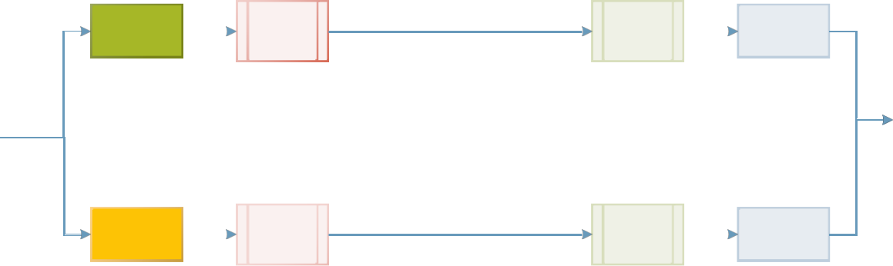

|  |  |  |  |  |  |  |
| --- | --- | --- | --- | --- | --- | --- |
|  |  | Down | Up |  | Inverse Low |  |
| Low Pass |  | Sample | Sample |  |  |
|  |  | Pass |  |
|  |  | by 2 | by 2 |  |  |
|  |  |  |  |  |
|  |  |  | I-Dimensional, I-Octave DWT and Inverse DWT |  |  |  |

**3.2.4 Stationary Wavelet Transform**

The Stationary wavelet transform (SWT) is a wavelet transform algorithm designed to overcome the lack of translation-invariance of the discrete wavelet transform (DWT). Translation-invariance is achieved by removing the downsamplers and upsamplers in the DWT and upsampling the filter coefficients by a factor of 2 −1 in the jth level of the algorithm.

The SWT is an inherently redundant scheme as the output of each level of SWT contains the same number of samples as the input – so for a decomposition of N levels there is a redundancy of N in the wavelet coefficients.

**3.2.4.1 SWT Implementation**

**SWT Decomposition**

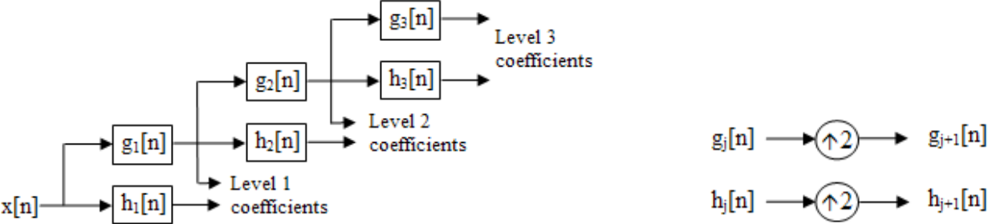

1. **PCA REDUCTION OF EEG SIGNALS**

The value of the cumulative variance accounted for by principle components.

|  |  |  |  |  |
| --- | --- | --- | --- | --- |
| 1. | 0.8365 | 9. | 0.9927 | 17. 0.9990 |
| 2. | 0.9177 | 10. | 0.9943 | 18. 0.9993 |
| 3. | 0.9570 | 11. | 0.9956 | 19. 0.9995 |
| 4. | 0.9699 | 12. | 0.9965 | 20. 0.9997 |
| 5. | 0.9794 | 13. | 0.9973 | 21. 0.9999 |
| 6. | 0.9842 | 14. | 0.9978 | 22. 1.0000 |
| 7. | 0.9882 | 15. | 0.9982 |  |
| 8. | 0.9907 | 16. | 0.9986 |  |

The plot shows to cumulative variance accounted for by the components in the bottom plot and the variance accounted for by each variable in the top plot. We can clearly see that a lot of compression is directly possible without using any auto regressive methods or cross regression methods.

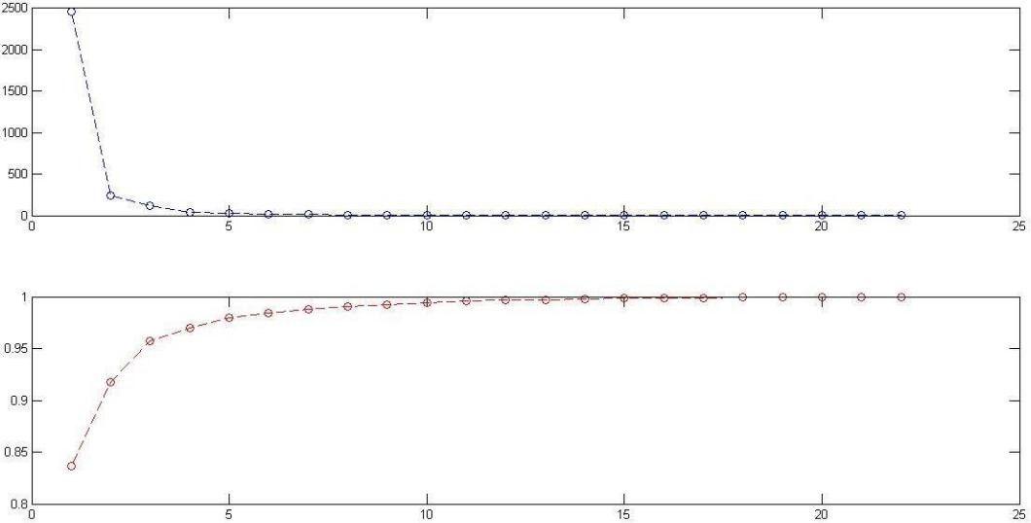

It is observed that the number of channels of independent data that are needed for complete representation are 2-3. This is a vast potential for data compression that has been exploited. Further work can be done in terms of the above indicated autoregressive and cross regressive terms that have the potential to reduce the number of variables even further vastly.

1. **ARTIFACT REDUCTION USING EOG SIGNALS**

Using the availability of EOG signal data, we can reduce the Artifacts in the EEG data in all channels through estimation of the channel between the EOG and each channel of EEG electrodes. The estimation can be done by many different algorithms. In this project the first attempt made was an adaptive filter. Here the adaptive filter is given the inputs of the 3 EOG channels and is tasked with the estimation of the EEG channel.

**5.1.1** **Basic Adaptive filtering**

The results from the application of APRU algorithm based adaptive filter to the EEG signal is shown below.

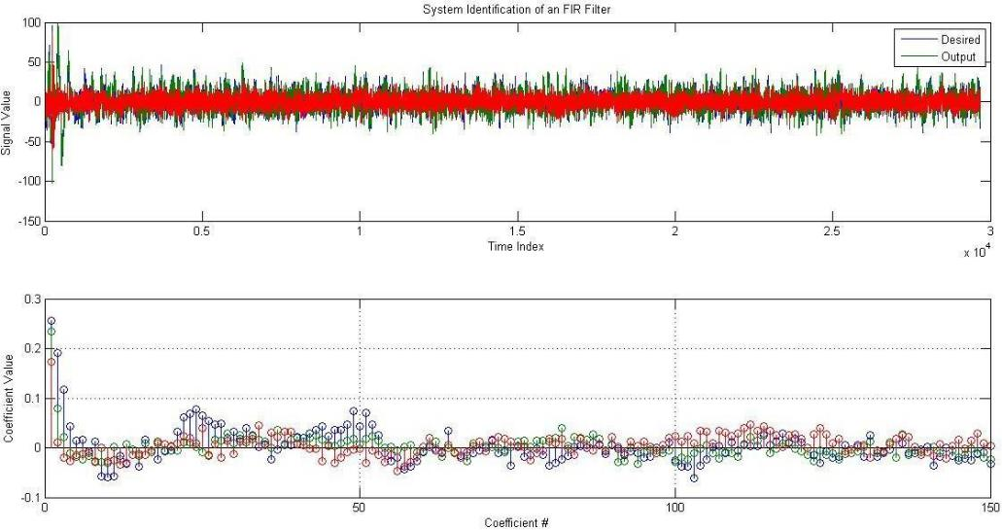

The blue signal is the original EEG signal observed in a rest state with only EOG artifacts affecting it. The green signal is the estimated signal from the adaptive filter and the red signal is the error between the two. We observe that the estimated signal fits moderately well and the error that remains un-estimated is mainly noise.

**5.1.2 Conditioning of EOG signals**

Considering a vector representation of the EOG signals it is observed that they tend to be non-orthogonal to each other and often have large components in common. This essentially means that the adaptive filters applied to each EOG signal try to estimate the EEG signal based on the

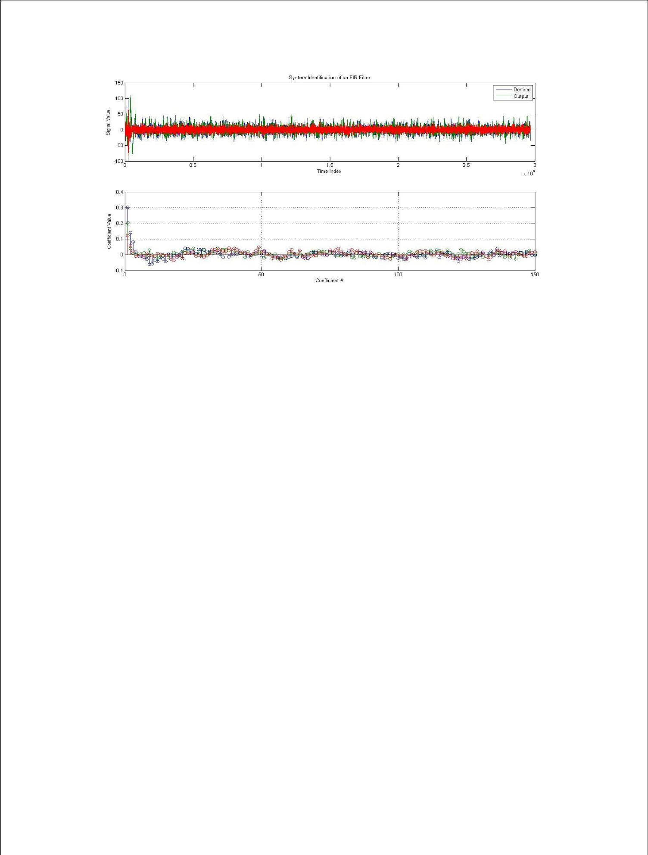

same common input in three different stages. This is generally detrimental to the learning performance of the adaptive filters. To mitigate this effect we use the PCA algorithm to ensure that the channels of EOG are orthogonal to each other. As the filter is essentially a linear algorithm and only first order independence (orthogonality) is required to ensure optimal performance, the PCA algorithm suffices.

The plot after this modification is shown above. The performance of the filter is seen to have improved and the coefficients of the filter shown in the second plot are much less noisy and well-conditioned than the first set of results.

**5.1.1 Stationary Wavelet Transform as a preprocessing method**

The SWT or Stationary Wavelet Transform can be applied to the data prior to adaptive filtering to increase the resolution and accuracy of the filters. As each channel of the transformed data can be approximately thought of as being approximately one band of frequencies, the adaptive filter when applied to each channel independently have a much more accurate filter response. Moreover the noise in the system that cannot be modeled are generally in different scales from the genuine artifact response and hence do not affect the coefficients in the learning process. The effects of using this method are dramatic as shown below.

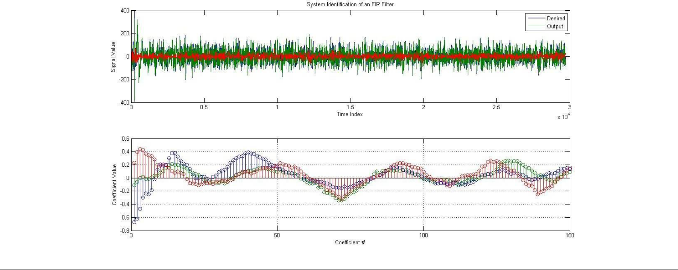

We can see that the un-modeled error is negligible and the filter coefficients are excellently conditioned. Thus the EOG based artifact correction algorithm is chosen as APRU based adaptive filter with SWT based preprocessing.

**5.2** **INTERPRETATION OF THE FILTER COEFFICIENTS**

The filter coefficients can be thought of as modelling the channel characteristics between each EOG electrode and the EEG electrode corresponding to that filter. Observing the characteristics of the coefficients and verifying them with the physically observed characteristics of the corresponding areas in the head can be a good measure of the accuracy of the filter. The plots below show the characteristics of the filters developed for each channel of EOG.

The first filter shows that magnitude response remains almost constant and has no significant effect while the phase plot shows that the EEG interference is simply a delayed version of the EOG signal with different delays for different frequency ranges. We also observe large flat zones where the phase response remains constant. Similar observations are made about channel 2. Channel 3 is observed to have an approximately linear phase while showing no significant trend in the magnitude response and we can infer that the third principle component models mainly noise that has no correspondence with the interference to EEG signals.

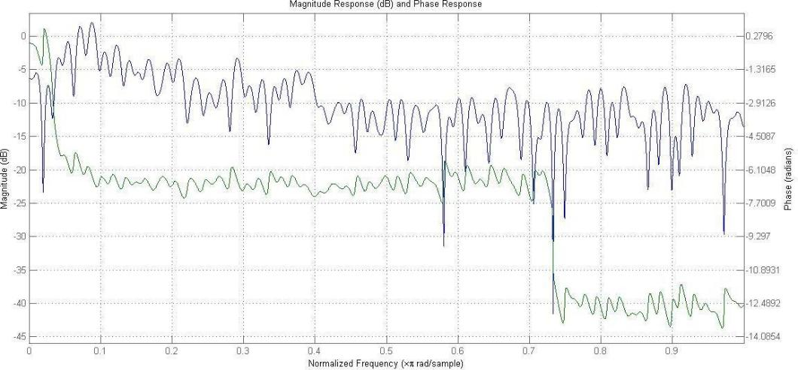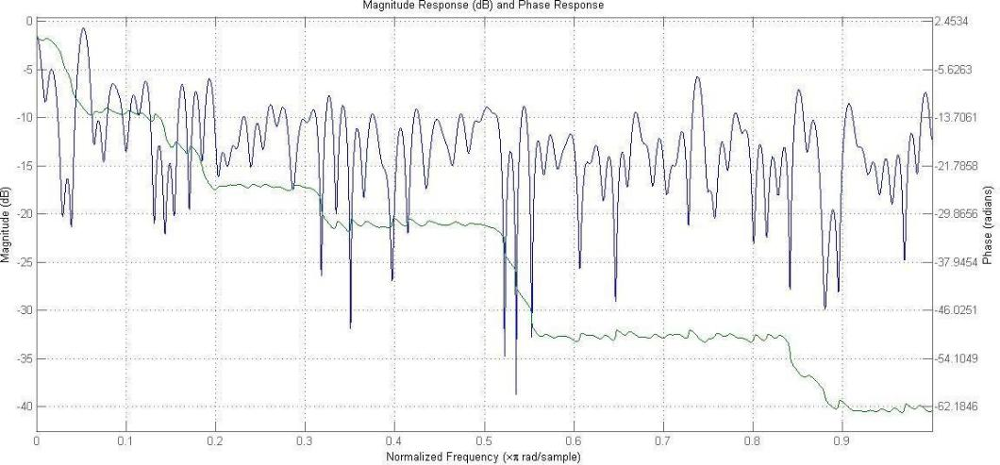

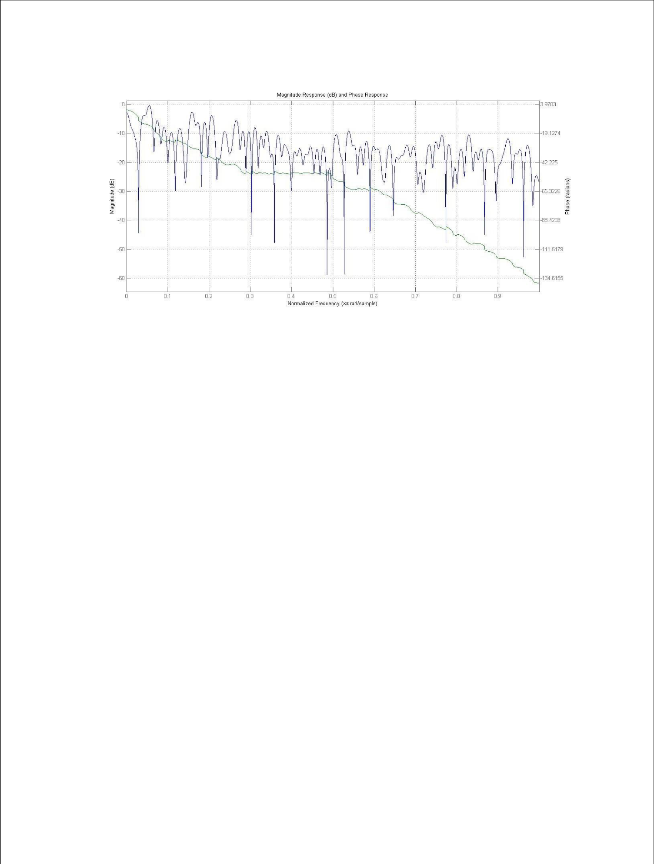

This interpretation can be verified from literature where the EEG interference has been observed to be modeled well by the shifted versions of the EOG signals. Thus we can conclude that the adaptive filter is a good approach to artifact cancellation with EOG data given.

1. **SPATIAL FILTERING**

**6.1** **NEUROPHYSIOLOGICAL BACKGROUND**

Macroscopic brain activity during resting wakefulness comprises distinct “idle” rhythms located over various cortical areas, e.g. the occipital α-rhythm (8–12 Hz) can be measured over the visual cortex. The perirolandic sensorimotor cortices show rhythmic macroscopic EEG oscillations (μ-rhythm, sensori motor rhythm, SMR) [20], [24] with spectral peak energies of about 9–14 Hz (localized predominantly over the post-central somatosensory cortex) and around 20 Hz (over the pre-central motor cortex). The occipital α-rhythm is quite prominent and can be seen in the raw EEG with the naked eye if the subject closes the eyes (idling of the visual cortex). In contrast the μ-rhythm has a much weaker amplitude and can only be observed after appropriate signal processing. In some subjects no μ-rhythm can be observed in scalp EEG. Our system is based on the modulation of the SMR. In fact, motor activity, both actual and imagined] as well as somatosensory stimulation have been reported to modulate the μ-rhythm. Processing of motor commands or somatosensory stimuli causes an attenuation of the rhythmic activity termed event-related de-synchronization (ERD), while an increase in the rhythmic activity is termed event related synchronization (ERS). For BCIs, the important fact is that the ERD is caused also by imagined movements (healthy users, see Figure 2) and by intended movements in paralyzed patients [2].

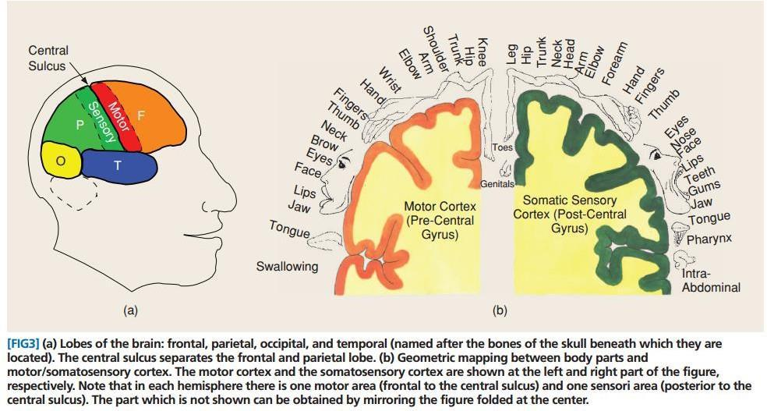

**6.2** **NEED FOR SPATIAL FILTERING**

Raw EEG scalp potentials are known to have a poor spatial resolution owing to volume conduction. In a simulation study only half the contribution to each scalp electrode came from sources within a 3 cm radius. This is in particular a problem if the signal of interest is weak, e.g. sensorimotor rhythms, while other sources produce strong signals in the same frequency range like the α-rhythm of the visual cortex or movement and muscle artifacts. The demands are carried to the extremes when it comes to single-trial analysis as in BCI. While some approaches try to achieve the required signal strength by training the subjects an alternative is to calibrate the system to the specific characteristics of each user. For the latter, data-driven approaches to calculate subject-specific spatial filters have proven to be useful. As a demonstration of the importance of spatial filters, Figure 4 shows spectra of left versus right hand motor imagery at the right hemispherical sensorimotor cortex. All plots are computed from the same data but using different spatial filters. While the raw channel only shows a peak around 9 Hz that provides almost no discrimination between the two conditions, the bipolar and the common average reference filter can improve the discrimination slightly. However, the Laplace filter and even more the CSP filter reveal a second spectral peak around 12 Hz with strong discriminative power. By further investigations, the spatial origin of the non-discriminative peak could be traced back to the visual cortex, while the discriminative peak originates from sensorimotor rhythms. Note that in many subjects, the frequency ranges of visual and sensorimotor rhythms overlap or completely coincide.

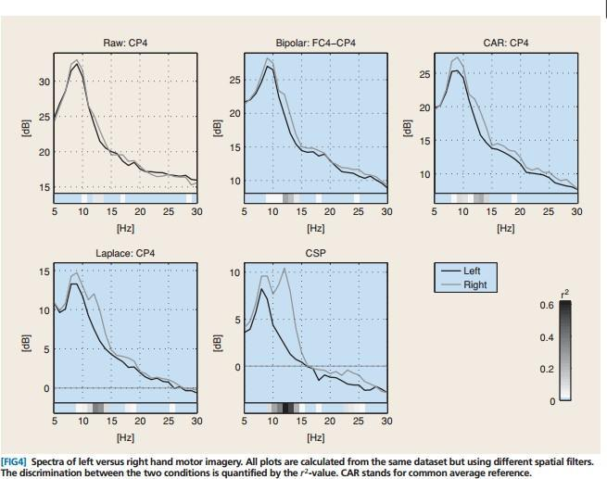

So we can observe that spatial filtering can bring out strong discriminative characteristics that remain hidden in many users and can drastically improve classification accuracy. We have adopted a CSP based approach to spatial filtering as opposed to the other filters mentioned in this section.

**6.3** **INTRODUCTION TO CSP ANALYSIS**

CSP is a technique to analyze multichannel data based on recordings from two classes (conditions). CSP yields a data-driven supervised decomposition of the signal parameterized by a matrix

∈ (C being the number of channels) that projects the signal ∈ (T is the number of samples in single trial) in the original sensor space to ∈ , which lives in the surrogate sensor space, as follows:

()= ()

We call each column vector of W a spatial filter or simply a filter.

In a nutshell, CSP filters maximize the variance of the spatially filtered signal under one condition while minimizing it for the other condition. Since variance of band-pass filtered signals is equal to band-power, CSP analysis is applied to approximately band-pass filtered signals in order to obtain an effective discrimination of mental states that are characterized by ERD/ERS effects.

**6.4** **CSP RESULTS**

Some of the results obtained from CSP can be interpreted to show intuitively the working of CSP and conclusively prove its effectiveness in the selection of optimal spatial coefficients for classification purposes.

The first instance considered is the classification of left hand and right hand movement. The first and second class data was fed to the CSP algorithm and an optimal spatial filter for classification was developed. The obtained filters are shown below.

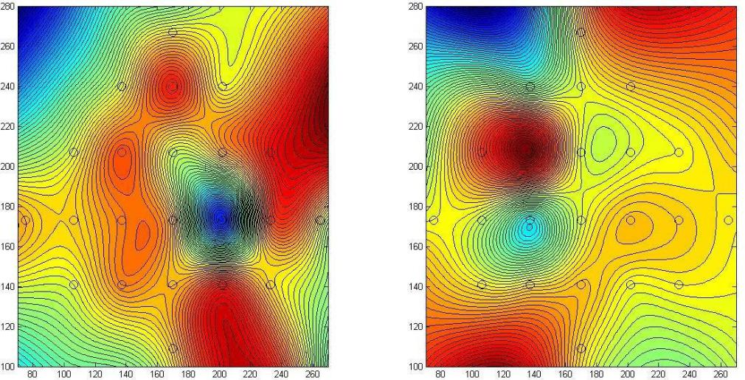

The above plot shows the coefficients of the filter across space as a gradient field. This representation allows us to visualize the effect of the filter on the selection of signals from the scalp. We can clearly see that the filter has shown a strong selectivity to the side of the brain meaning that it has identified the best possible differentiator between the classes i.e. the hemisphere of the brain in which activity occurs. This is just an example of the effectiveness of CSP for this problem.

CSP runs on binary input data but our classification problem has four classes, so we can adopt various strategies to convert the problem to a form amenable to CSP. These are:

**1. One versus rest problem**

Here each class is labelled as 1 first and the rest of the classes are labelled as 0 and a classification is performed. So we need as many classifiers as there are classes in the data

**2. Pair Wise Classification**

Each pair of classes are considered together and classified. After all the classifiers are developed, their outputs are considered for a polling and the net output class is chosen.

**3. Divide and Conquer**

This is similar to the one versus all approach but a tree based system is adopted for the classification meaning that the number of classifiers needed is the total number of classes-1

The plots below summarizes the value of the average power in each of the first and last eigenvalue spatial filter for the one versus all problems considered. This gives an approximate idea of how good the discrimination is after the application of the spatial filter.

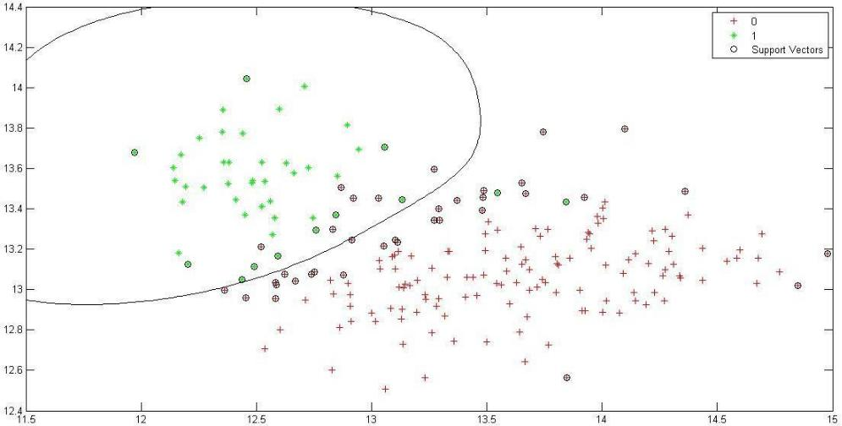

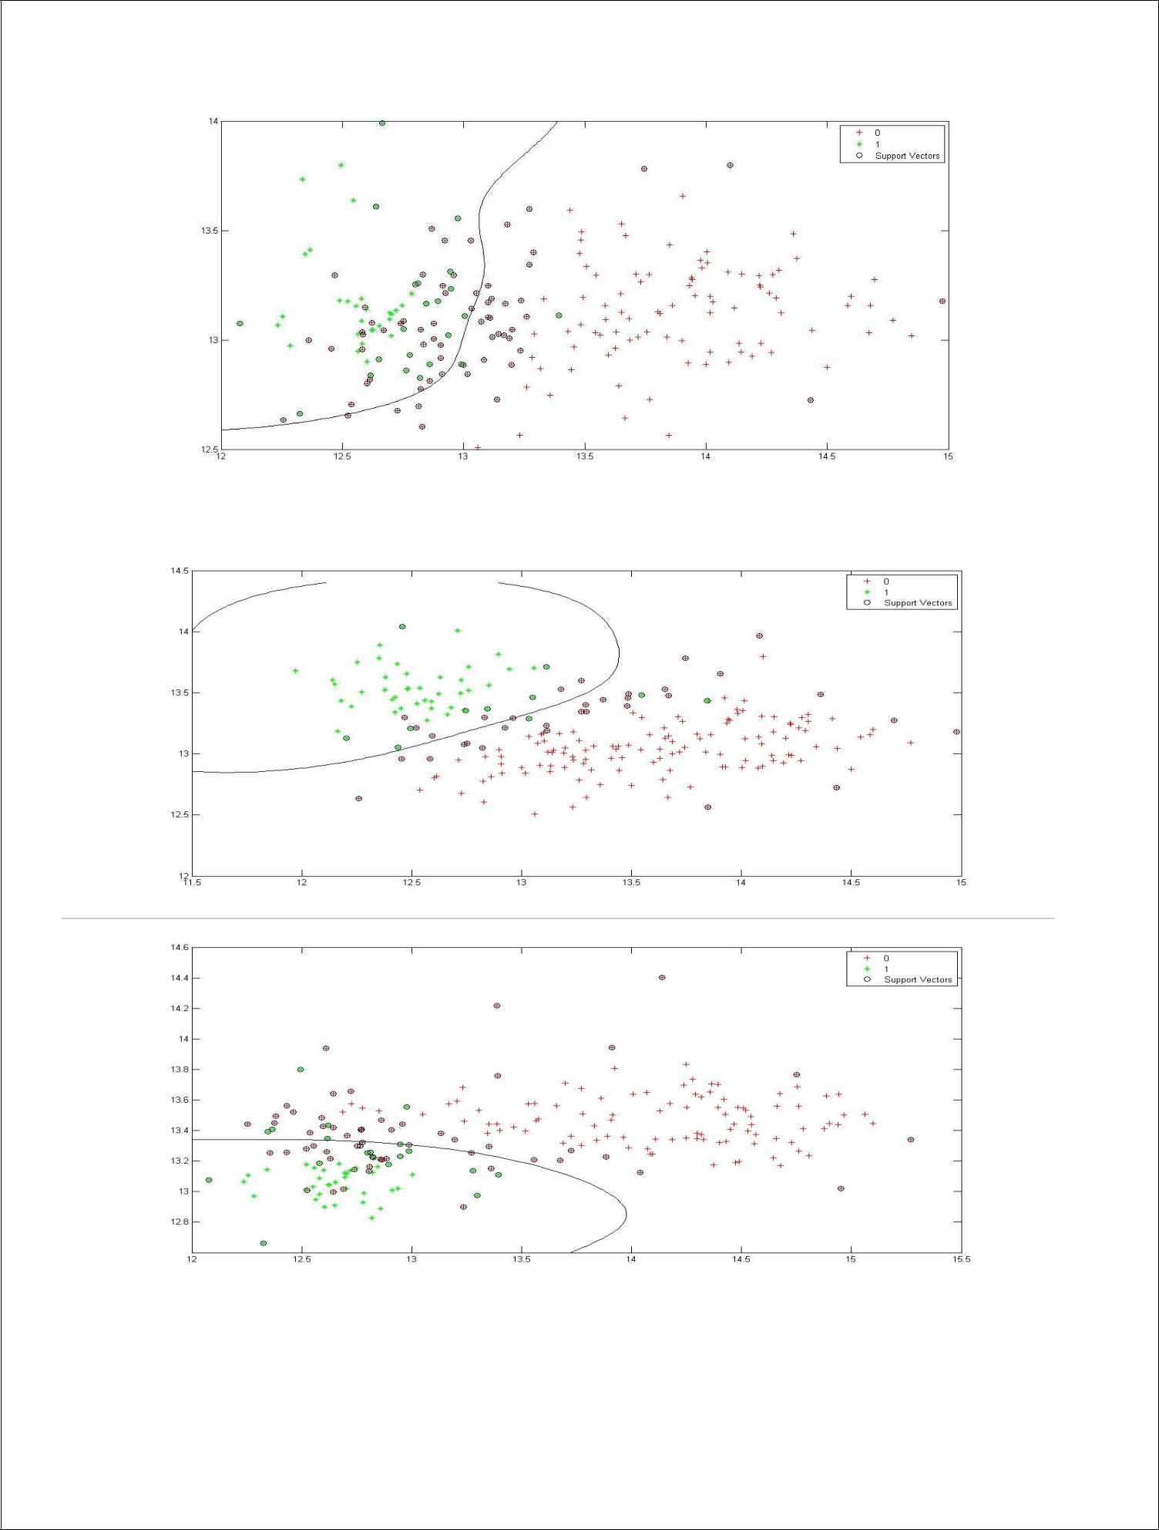

An even better picture can be obtained by plotting after normalization which aligns the point on a circular trajectory.

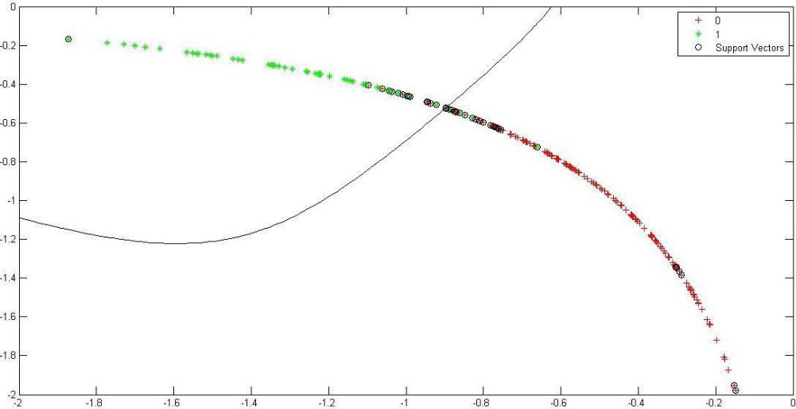

1. **CLASSIFICATION USING SUPPORT VECTOR MACHINE (SVM)**

**7.1** **SUPPORT VECTOR MACHINE**

In machine learning, support vector machines are supervised learning models with associated learning algorithms that analyze data and recognize patterns, used for classification and regression analysis. An SVM model is a representation of the examples as points in space, mapped so that the examples of the separate categories are divided by a clear gap that is as wide as possible. New examples are then mapped into that same space and predicted to belong to a category based on which side of the gap they fall on.

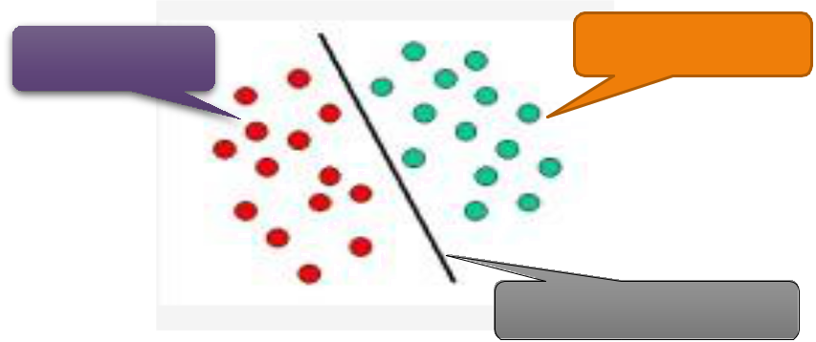

|  |  |  |
| --- | --- | --- |
| Class Red | Class Green |  |
|  |  |

Linear Decision Plane

More formally, a support vector machine constructs a hyperplane or set of hyperplanes in a high-or infinite-dimensional space, which can be used for classification, regression, or other tasks. There are many hyperplanes that might classify the data. One reasonable choice as the best hyperplane is the one that represents the largest separation, or margin, between the two classes. So we choose the hyperplane so that the distance from it to the nearest data point on each side is maximized. If such a hyperplane exists, it is known as the maximum-margin hyperplane and the linear classifier it defines is known as a maximum margin classifier.

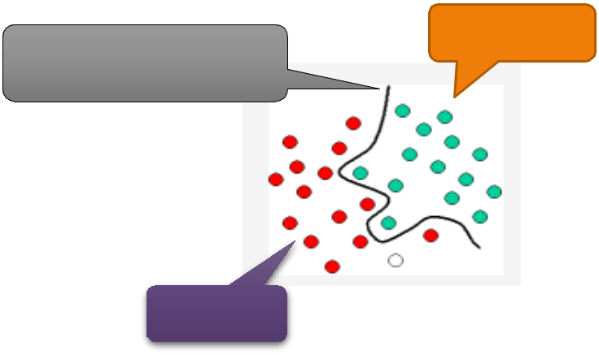

Class Green

Non-Linear Decision Plane

Class Red

Whereas the original problem may be stated in a finite dimensional space, it often happens that the sets to discriminate are not linearly separable in that space. For this reason, it was proposed that the original finite-dimensional space be mapped into a much higher-dimensional space, presumably making the separation easier in that space. To keep the computational load reasonable, the mappings used by SVM schemes are designed to ensure that dot products may be computed easily in terms of the variables in the original space, by defining them in terms of a kernel function K(x,y) selected to suit the problem.

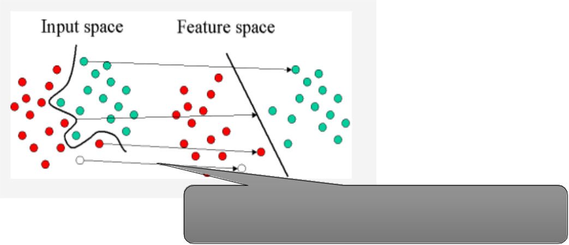

**7.1.1 Mathematical Explanation**

Given some training data , a set of *n* points of the form:



where the *yi* is either 1 or −1, indicating the class to which the point  belongs. Each  is a *p*-dimensional real vector. We want to find the maximum-margin hyperplane that divides the

points having  from those having . Any hyperplane can be written as the set of points  satisfying



where dot(.) denotes the dot product and  the (not necessarily normalized) normal vector to the hyperplane.

Maximum-margin hyperplane and margins for an SVM trained with samples from two classes. Samples on the margin are called the support vectors.

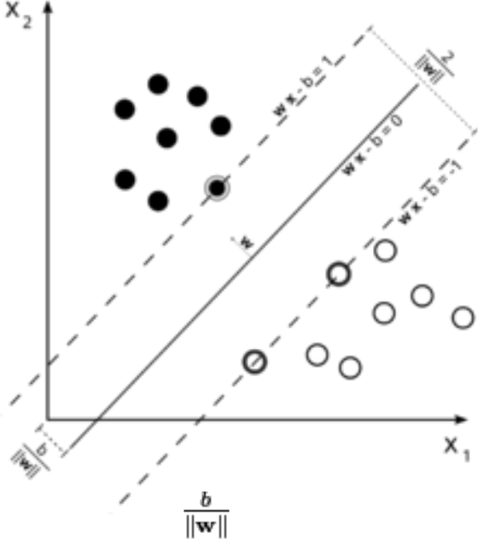

The parameter .

determines the offset of the hyperplane from the origin along the normal vector

If the training data are linearly separable, we can select two hyperplanes in a way that they separate the data and there are no points between them, and then try to maximize their distance. The region bounded by them is called "the margin". These hyperplanes can be described by the equations



and



By using geometry, we find the distance between these two hyperplanes is , so we want to

minimize . As we also have to prevent data points from falling into the margin, we add the following constraint: for each either

of the first class

or

 of the second.

This can be rewritten as:



We can put this together to get the optimization problem:

Minimize (in )  subject to (for any )



1. **MATLAB CODE**

Included in this section are all the MATLAB codes implemented as part of this project.

8.1 CODE FOR ORGANIZING DATA INTO A READABLE FORMAT

clc; clear all;

[s,h]=sload('D:\Acad\Sem 6\EEG Signal processing\Data\EEG +Eog\A01T.gdf');

pos=h.EVENT.POS;

dur=h.EVENT.DUR;

typ=(h.EVENT.TYP==769)+2.*(h.EVENT.TYP==770)+3.*(h.EVENT.TYP==771)...

+4.*(h.EVENT.TYP==772)+100.*(h.EVENT.TYP==768)+101.*(h.EVENT.TYP==1023)...

+1000.*(h.EVENT.TYP==32766)+150.*(h.EVENT.TYP==276)+151.*(h.EVENT.TYP==277)+1

52.*(h.EVENT.TYP==1072);

info=[typ pos pos+dur];

* EEG with only EOG effects d=s(50056:91518,1:22); x1=s(50056:91518,23); x2=s(50056:91518,24); x3=s(50056:91518,25); count=0;

d=d';

temp1=isnan(d); if(sum(max(temp1))~=0) count=count+1 [row1,col1]=find(temp1); row1=unique(row1);

for z=1:size(row1,1) tdata1=iddata(d(row1(z),:)',[],250); tintp1=misdata(tdata1); d(row1(z),:)=(tintp1.OutputData)'; end

end

* Event Data

j=1;class=[];

for i=1:size(info,1)

if (info(i,1)==100)

if (info(i+1,1)~=101)

class(j,1)=info(i+1,1);

data{j}=s(info(i,2):info(i,3),:)';

j=j+1;

end

end

end

dat=cell(4,25);

for i=1:size(class,1)

for j=1:25

dat{class(i,1),j}=[dat{class(i,1),j}; data{1,i}(j,:)];

end

end

* end

%%

j=1;class_c=[];

for i=1:size(info,1) if (info(i,1)==100) if (info(i+1,1)==101) class_c(j,1)=info(i+2,1);

data_c{j}=s(info(i+1,2):info(i+1,3),:)'; j=j+1;

end end end

%% Interpolate Incomplete Data count=0;

for i=1:4 for j=1:25 temp=isnan(dat{i,j});

if(sum(max(temp))~=0) count=count+1 [row,col]=find(temp); row=unique(row);

for z=1:size(row,1) tdata=iddata((dat{i,j}(row(z),:))',[],250); tintp=misdata(tdata); dat{i,j}(row(z),:)=(tintp.OutputData)'; end

end

end end

%%

count=1;

data_new=cell(273,1); %y1=sort(class);y=class; for i=1:4

for k=1:size(dat{i,1},1) for j=1:25

data_new{count}=[data_new{count};dat{i,j}(k,:)];

end count=count+1; end

end

%save('C:\Users\Shriram\Desktop\Data_Raw.mat','dat','y1');

save('C:\Users\Shriram\Desktop\Data_Raw_Unord.mat','data_new','y');

%%

datcpress=cell(1,22);compress=[]; for i=1:25 p=[dat{1,i};dat{2,i};dat{3,i};dat{4,i}]; [pc,score,latent,tsquare] = princomp(p); pcomre=pc(:,1:10); datcpress{i}=p*pcomre; compress=[compress datcpress{i}];

end

8.2 ARTIFACT REMOVAL WITH ADAPTIVE FILTERING

clear all;

load('C:\Users\Shriram\Desktop\eeg_eog.mat'); [COEFF,SCORE,latent] = princomp(eeg'); eeg_c=(eeg'*COEFF)';

d = eeg_c(1,:);

d=padarray(d,[0 13],'symmetric','post'); ds=swt(d,4,'sym3');

%% APRU Algorithm with prefiltered eog & eeg

order=200;

[COEFF,SCORE,latent] = princomp(eog');

eogf=eog'*COEFF;

eogf=padarray(eogf,[13 0],'symmetric','post');

mu = 0.08; % Step size

po = 2; % Projection order

offset = 0.05; % Offset

dfilt=ds;

for i=5:5

ha1(i) = adaptfilt.apru(order,mu,po,offset); [y1,e1] = filter(ha1(i),eogf(:,1)',ds(i,:));

ha2(i) = adaptfilt.apru(order,mu,po,offset); [y2,e2] = filter(ha2(i),eogf(:,2)',e1);

ha3(i) = adaptfilt.apru(order,mu,po,offset); [y3,e3] = filter(ha3(i),eogf(:,3)',e2);

dfilt(i,:)=y1+y2+y3;

end

%%

y=iswt(dfilt,'sym3');

figure,subplot(2,1,1); plot(1:size(d,2),[d;y;d-y]); title('System Identification of an FIR Filter'); legend('Desired','Output');

xlabel('Time Index'); ylabel('Signal Value');

subplot(2,1,2); stem(1:size(ha1(1,5).coefficients,2),[ha1(1,5).coefficients' ha2(1,5).coefficients' ha3(1,5).coefficients']);

xlabel('Coefficient #'); ylabel('Coefficient Value'); grid on;

8.3 COMMON SPATIAL PATTERNS PROGRAM

function [unmixing] = csp_custom(dat1, dat2)

* CSP Common spatial pattern decomposition
* This implements Ramoser, H., Gerking, M., and Pfurtscheller, G. "Optimal
* spatial filtering of single trial EEG during imagined hand movement."

% IEEE Trans. Rehab. Eng 8 (2000), 446, 441.

R1=zeros(size(dat1{1},1));

R2=zeros(size(dat1{1},1));

for i=1:size(dat1,1)

R1_temp = dat1{i}*dat1{i}';

R1_temp = R1_temp/trace(R1_temp);

R1=R1+R1_temp;

end

R1=R1./size(dat1,1);

for i=1:size(dat2,1)

R2_temp = dat2{i}*dat2{i}';

R2_temp = R2_temp/trace(R2_temp);

R2=R2+R2_temp;

end

R2=R2./size(dat2,1);

* R2 = dat2*dat2';
* R2 = R2/trace(R2);
* Ramoser equation (2) Rsum = R1+R2;
* Find Eigenvalues and Eigenvectors of RC
* Sort eigenvalues in descending order [EVecsum,EValsum] = eig(Rsum); [EValsum,ind] = sort(diag(EValsum),'descend'); EVecsum = EVecsum(:,ind);
* Find Whitening Transformation Matrix - Ramoser Equation (3) W = sqrt(pinv(diag(EValsum))) * EVecsum';
* Whiten Data Using Whiting Transform - Ramoser Equation (4) S1=W*R1*W';

S2=W*R2*W';

* Ramoser equation (5)
* [U1,Psi1] = eig(S1);
* [U2,Psi2] = eig(S2);
* Generalized eigenvectors/values

[B,D] = eig(S1,S2);

* Simultanous diagonalization
* Should be equivalent to [B,D]=eig(S1);
* Verify algorithim
* Disp('test1:Psi1+Psi2=I')
* Psi1+Psi2
* Sort ascending by default



* [Psi1,ind] = sort(diag(Psi1)); U1 = U1(:,ind);
* [Psi2,ind] = sort(diag(Psi2)); U2 = U2(:,ind);

[D,ind]=sort(diag(D));

B=B(:,ind);

%Resulting Projection Matrix-these are the spatial filter coefficients unmixing = B'*W;

8.4 SUPPORT VECTOR MACHINES FOR CLASSIFICATION

%% Support Vector Machines

opts = statset('MaxIter',30000);

* Train the classifier svmStruct =

svmtrain(Xtrain,Ytrain,'showplot',true,'kernel_function','rbf','rbf_sigma',1, 'kktviolationlevel',0,'options',opts);

* Make a prediction for the test set
* Examine the confusion matrix for each class as a percentage of the true class

C_svm = bsxfun(@rdivide,C_svm,sum(C_svm,2)) * 100 figure;

plotconfusion(Ytest',Y_svm') %error rate 100*(1-sum(abs(Y_svm-Ytest))./109)

8.5 COMPLETE PROGRAM EXECUTING ALL COMPONENTS TO MAKE A COMPLETE PREDICTION

clc; clear all;

load('tldata1.mat');

[b,a]=butter(5,[8/125,30/125],'bandpass');

%data3=[data1;data2];

y=zeros(size(data3,1),1);

* Filtering Data for i=1:size(data3,1) for j=1:44 %data3{i}=data3{i}(:,625:1500); data3{i}(j,:)=filter(b,a,data3{i}(j,:)); end

end

% for i=1:size(data1,1)

% for j=1:size(data1{i},2)

%data1{i}(:,j)=(data1{i}(:,j)'-mean(data1{i}'))';

* end
* end
* for i=1:size(data2,1)
* for j=1:size(data2{i},2)
* data2{i}(:,j)=(data2{i}(:,j)'-mean(data2{i}'))';
* end
* end

%%

clas=1;

if clas==1

data1=data3(1:69); data2=[data3(70:end)];%data3(207:end)]; k1=1;k2=3;

end

if clas==2

data1=data3(70:138); data2=[data3(1:69);data3(139:end)]; k1=1;k2=2;

end

if clas==3

data1=data3(139:206); data2=[data3(1:138);data3(207:end)]; k1=2;k2=3;

end

if clas==4

data1=data3(1:206); data2=[data3(207:end)]; k1=1;k2=3;

end

y(1:size(data1,1))=1;

%%

W=csp_custom(data1,data2);

for i=1:size(data1,1)

Z=W*data1{i};

datacsp_1{i}=[Z(1:1,:);Z(22:22,:)];

end

for i=1:size(data2,1)

Z=W*data2{i};

datacsp_2{i}=[Z(1:1,:);Z(22:22,:)];

end

datacsp=[datacsp_1';datacsp_2'];

dat_mat_1=[];dat_mat_2=[];

for i=1:(size(data1,1)+size(data2,1))

dat_mat_1=[dat_mat_1;datacsp{i,1}(1,:)];dat_mat_2=[dat_mat_2;datacsp{i,1}(2,:

)];

dat_classify(i,:)=log(diag(datacsp{i,1}*datacsp{i,1}'));%./trace(datacsp{i,1} *datacsp{i,1}'));

end

* Prepare the Data: Response and Predictors % Response

Y = y;

tabulate(Y)

% Predictor matrix

X = double(dat_classify(:,1:end));

* we will hold 20% of the data, selected randomly, for
* test phase.

cv = cvpartition(length(dat_classify),'holdout',0.2);

% Training set

Xtrain = X(training(cv),:);

Ytrain = Y(training(cv),:);

% Test set

Xtest = X(test(cv),:);

Ytest = Y(test(cv),:);

disp('Training Set')

tabulate(Ytrain)

disp('Test Set')

tabulate(Ytest)

%% Support Vector Machines

opts = statset('MaxIter',30000);

* Train the classifier svmStruct =

svmtrain(Xtrain,Ytrain,'showplot',true,'kernel_function','rbf','rbf_sigma',1, 'kktviolationlevel',0,'options',opts);

* Make a prediction for the test set
* Examine the confusion matrix for each class as a percentage of the true class

C_svm = bsxfun(@rdivide,C_svm,sum(C_svm,2)) * 100 figure;

plotconfusion(Ytest',Y_svm') %error rate 100*(1-sum(abs(Y_svm-Ytest))./109)

%% Show CSP data

load('Plotcoords.mat');

gx=70:270;

gy=100:280;

zz=gridfit(Xaxis,Yaxis,W(1,:),gx,gy);

figure;

subplot(1,2,1),contourf(gx,gy,zz,70)

hold on

set(gca,'color','none')

subplot(1,2,1),scatter(Xaxis,Yaxis,100,'k')

zz=gridfit(Xaxis,Yaxis,W(22,:),gx,gy);

subplot(1,2,2),contourf(gx,gy,zz,70)

hold on

set(gca,'color','none')

subplot(1,2,2),scatter(Xaxis,Yaxis,100,'k')

subplot(2,2,3),zz=gridfit(Xaxis,Yaxis,W(2,:),gx,gy);

contourf(gx,gy,zz,70)

hold on

set(gca,'color','none')

subplot(2,2,2),scatter(Xaxis,Yaxis,100,'k')

subplot(2,2,4),zz=gridfit(Xaxis,Yaxis,W(21,:),gx,gy);

contourf(gx,gy,zz,70)

hold on

set(gca,'color','none')

subplot(2,2,2),scatter(Xaxis,Yaxis,100,'k')

1. **RESULTS**

We have successfully classified the movements of left hand, right hand, legs and tongue into four classes respectively. 75 % of the data has been used as the training set to train the classifier and the rest of the data has been used as the testing set. The following confusion matrices have been obtained for respective movements.

1.Classification rate of class_1=97.8947% 2.Classification rate of class_2=95.7895%

3.Classification rate of class_3=91.2435% 4.Classification rate of class_4=93.6842%

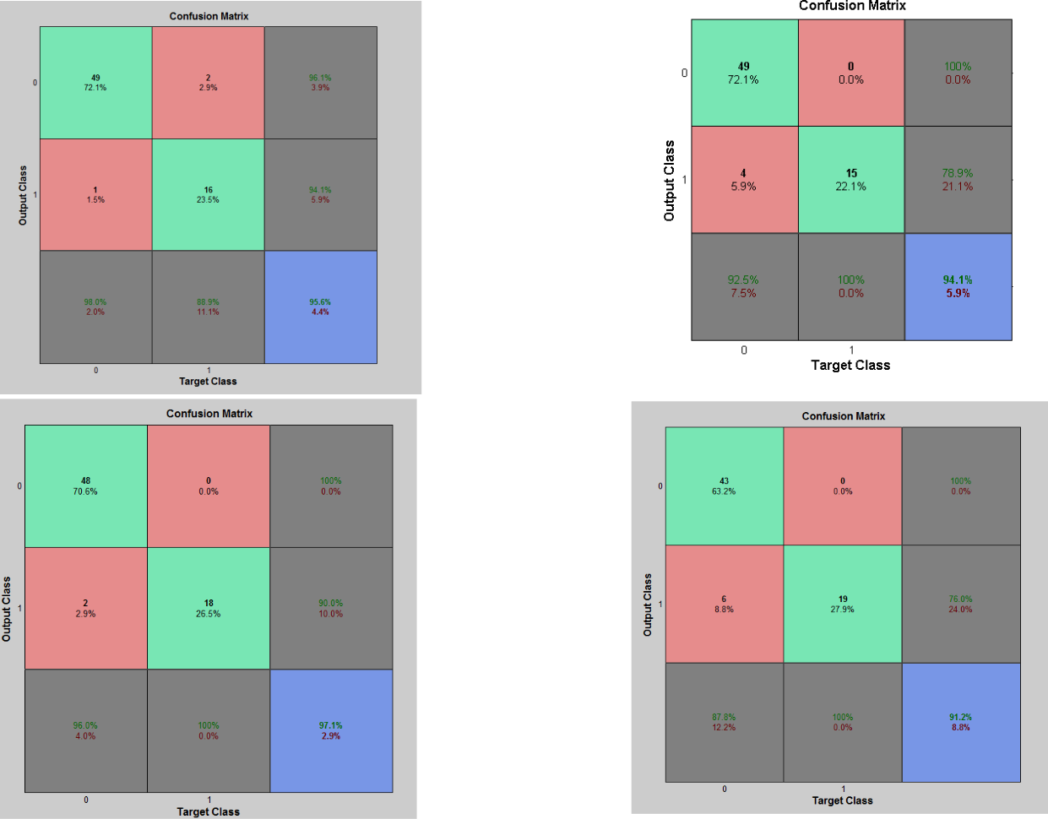

1. **FUTURE DIRECTIONS**

**RO1:** To decompose EEG signals and to analyse the cognitive load index, band ratio’s, prefrontal electrode, individual band frequencies of the subjects and binary classification with different classifier.

**RO2:** To analyse and implement a different classifier using machine learning techniques for classification of brain lobe areas and pair-wise electrode combination.

**RO3:** To propose a novel technique using transformer-based model for classification.

**RO4:** To propose a novel technique using convolution layers, resnet layer along with transformer for classification.

1. **REFERENCES**
   1. BCI Competition 2008 { Graz data set A} C Bruner et al
   2. A. Kübler, F. Nijboer, J. Mellinger, T.M. Vaughan, H. Pawelzik, G. Schalk,

D.J. McFarland, N. Birbaumer, and J.R. Wolpaw, “Patients with ALS can use sensorimotor rhythms to operate a brain-computer interface,” Neurology, vol. 64, no. 10 pp. 1775–1777, 2005.

* 1. The Wavelet Tutorial,

Website: <http://users.rowan.edu/~polikar/WAVELETS/WTpart1.html>

1. Stationary Wavelet Transform

Website: en.wikipedia.org/wiki/**Stationary**_**wavelet**_**transform**

1. Discrete Stationary Wavelet Transform

Website: <http://www.mathworks.in/help/wavelet/ug/discrete-stationary-wavelet-transform-swt.html>

1. Support Vector Machines Tutorial Website: <http://www.cs.columbia.edu/~kathy/cs4701/documents/jason_svm_tutorial.pdf> <https://www.statsoft.com/textbook/support-vector-machines>
2. Machine Learning with MATLAB

Website: [www.mathworks.in/videos/machine-learning-with-matlab-81984.html](http://www.mathworks.in/videos/machine-learning-with-matlab-81984.html)

1. Common Spatial Pattern Website: <http://www.slideshare.net/yokotatsuya/introduction-to-common-spatial-pattern-filters-for-eeg-motor-imagery-classification>
2. Common Spatial Pattern Method for Channel Selection in Motor Images based BCI.

Website: sccn.ucsd.edu/~yijun/pdfs/EMBC05.pdf

1. Analysis and simulation of brain signal data by EEG signal processing technique using MATLAB**-** Guru murthy.
2. Monitoring of micro-sleep and sleep states using EEG signals- Miguel Rivera.